Samos setup for Orange Pi Prime with official Skywire images
Some of the steps may be unnecessary in the future, some other might be required.

1) Terms:
Orange Pi Prime – OPP
Home network router – HR
Skyminer router – SR
OPP with installed skywire and additional hard drive (via USB) – The Node / Node

2) Requirements:
- Basic linux skills
- Orange Pi Prime with working official skywire image ( https://github.com/skycoin/skywire#download-system-images )
- Public static IP address
- Access to home network router access and skyminer router.
- Samos Storage Node Test Run Manual ( for section 3.D )
- USB to SATA adapter
  - OPPs have only USB 2.0, so you don't need 3.0
  - SSD disks can usually run on 5V and less than 1A, classic HDDs (preferable for often changed data) usually need 12V and less than 1A. These informattion are always written on the disks.
If your disk requires more than 5V you need to buy adapter cable with power adapter, such as https://www.amazon.com/WEme-Converter-Adapter-Drive-included/dp/B00MVRS38G/. OPP won't give you more than 5V.
  - You don't need adapter if you have MicrroSD card with over 100GB, that are required for whitelist.

3) Step by step guide:
Be sure you are connected to the network, and plug your disk drive to the USB.
A) Networking
Access your HR. If you are not sure about the address, just write ipconfig (windows) or ifconfig (linux) to the command line / terminal on your PC. Then find IP and MAC address of your SR and write them down.
Add reserved rule in your HR for the SR so that it always has the same address. You can usually find it under DHCP settings, but it depends on type of the router / software.
Find Port forwarding and forward port 6666 to the IP address of the SR and its port 6666.
Previous steps will ensure that your SR will always get the same address inside your home network and that all the traffic coming to your publicIP:6666 will end up on the SR.
If you have node connected directly to your HR, you need to use MAC address of the OPP and the IP address has to be 192.168.0.2 – 0.9, depending on the image you used. You can skip the next step.
Now log in to your SR and find port forwarding again. Depending on the image you used, forward all the traffic from port 6666 to port 6666 of the IP address of the node, where you want to run Samos.
Troubleshoot:
If you don't know IP address of the node, you can connect directly to your SR and ping addresses 192.168.0.2 – 0.9. If you are not sure, what is the IP of the Node, use SSH connection to each one of them and call ifconfig ( for IP ) and lsblk ( so you see connected disk drives).
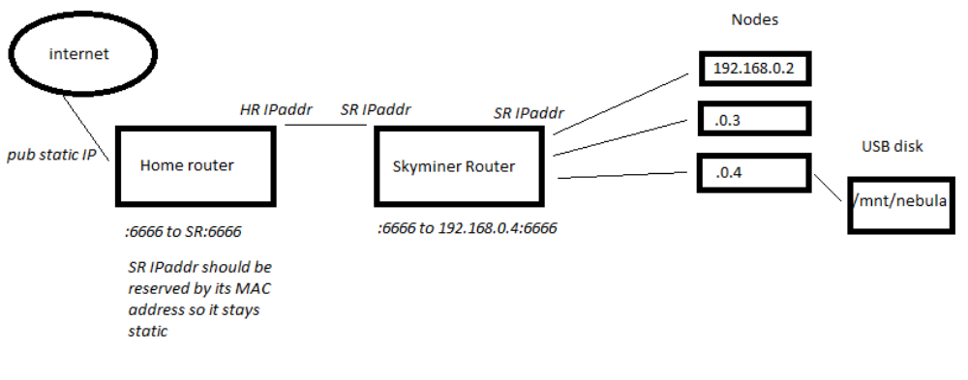
B) Additional Node setup
There are multiple important tools missing for easy and successful installation of the Nebula provider and formatting the disk (optional).
Access the node with SSH as root and run:
$ sudo apt-get install parted ntpdate bzip2
$ ntpdate pool.ntp.org
Parted is good for disk formatting, ntpdate will help us set up the date and time right and bzip2 will be used to untar tar.bz2 file with Nebula.
C) Formatting hard drive (optional)
If you need or want to format the harddrive you're going to use, here is simple and easy tutorial on how to do it https://www.digitalocean.com/community/tutorials/how-to-partition-and-format-storage-devices-in-linux. I recommend using GPT tables, but it's up to you. If you want to format all your disk and make it 1 partition, just go with this :
$ lsblk
and write down the NAME of the disk. Use it instead of $NAME on next lines
$ parted /dev/$NAME mklabel gpt
$ parted -a opt /dev/$NAME mkpart primary ext4 0% 100%
$ mkfs.ext4 -L datapartition /dev/$NAME+”1”
!!! if NAME is sda, then use /dev/sda1 in the command above
$ sudo mkdir -p /mnt/nebula
$ nano /etc/fstab
add line with
/dev/$NAME1 /mnt/nebula ext4 defaults 0 3
and ctrl + x, and save. Then run wa
$ sudo mount -a
and you are done. You can check the result with
$ df -h -x tmpfs -x devtmpfs
or
$ ls -l /mnt/nebula
D) Installing nebula provider, configuration
Go to https://github.com/samoslab/nebula/releases/ and find latest release for linux ARM7 tar.bz2 file and copy link address. For this tutorial we'll use current version https://github.com/samoslab/nebula/releases/download/0.8/nebula-provider-0.8.2-linux-armv7.tar.bz2.
Go to terminal and run (be sure to change the parameters in ./nebula-provider command, according to StorageNodeTestRunManual):
$ cd /bin
$ wget –no-check-certificate https://github.com/samoslab/nebula/releases/download/0.8/nebula-provider-0.8.2-linux-armv7.tar.bz2
$ tar xvjf nebula-provider-0.8.2-linux-arm7.tar.bz2
$ ./nebula-provider register -availability 99% -billEmail youremailaddress@domain.com -downBandwidth 100 -upBandwidth 20 -walletAddress yourwalletaddress - mainStoragePath /mnt/nebula -mainStorageVolume 800GB
If you followed this tutorial right and give nebula provider right parameters, you should get :
Register success, please get verify-code email to verify bill email and backup your config file: /xxx/yyy/config.json Please make a copy of the .json file for backup
along with the email. Be sure to backup your json file from /root/.samos-nebula-provider/. Then copy the code from your email and use this command :
$ ./nebula-provider verifyEmail -verifyCode verifyCodeCopyFromEmail
and finally:
$ nohup ./nebula-provider daemon &

ln case of errors please reffer to official manual or visit https://t.me/samosnode. If you find anything wrong with this manual or would like to add something important, use https://t.me/sn3hul4k.

